**Memorandum**

**To:** Dr. Sys Tems, CEO of “Sys Tems LLC”

**From:** Steve Tamayo, “Professional Staff Engineer”, Raymond Yung, “Professional Staff Engineer”, Duy Le, “Professional Staff Engineer”, Angela Albrecht, “Professional Staff Engineer”,

**CC:** Dr. Thomas Chmielewski, “Engineering Advisor”

**Date:** October XX, 2019

**Subject:** Ultrasonic Transducer Statistics and Calibration

Our engineering team has gathered ultrasonic transducer statistics to demonstrate a reliable calibration curve. We believe that obtaining a calibration curve is necessary for the company’s development of a Kalman filter which will require this sensor.

Figure 1. Ultrasonic Transducer Circuit

**Circuit Explanation**

The circuit of the ultrasonic sensor is connected as follows on the right in Figure 1. The sensor has 3 input pins for VCC, TRIG, and GND and one output pin for TRIG. The trig pin generates a pulse which the echo pin picks up and represents the time it takes for the signal to send, hit the target and then return back. In the team’s code, this time is divided by two in order to get the time it takes for the signal to only go forward.

Over 100 measurements were made for each of the following distances: 6 inches, 12 inches, 18 inches and 24 inches for three separate sensors. After recording the data points, the mean, variance and average difference from the initial value was calculated. The results are displayed in the table below.

Table 1. Variance and Mean of the Statistical Data for all 3 Sensors

|  |  |  |  |  |  |
| --- | --- | --- | --- | --- | --- |
|  | **inches:** | **6** | **12** | **18** | **24** |
| **Sensor 1** | Mean | 6.886805556 | 13.00930556 | 19.06131944 | 24.93423611 |
| Variance | 0.01086664724 | 0.0005757381507 | 0.00104649864 | 5.483979832 |
| DIFF | 0.8868055556 | 1.009305556 | 1.061319444 | 0.9342361111 |
| **Sensor 2** | Mean | 6.729440994 | 13.04614907 | 19.06515528 | 24.13167702 |
| Variance | 0.2288428106 | 0.0003413276398 | 0.0005601319876 | 18.0182278 |
| DIFF | 0.7294409938 | 1.046149068 | 1.06515528 | 0.1316770186 |
| **Sensor**  **3** | Mean | 6.848721805 | 12.93015038 | 19.00992481 | 24.85842105 |
| **Variance** | **0.00002032353611** | **0.001186340852** | **0.001888630668** | **0.0009073365231** |
| DIFF | 0.8487218045 | 0.9301503759 | 1.009924812 | 0.8584210526 |

From the mean and variance table above for all three sensors, we selected the third sensor due to its precise overshoot of 0.85 (DIFF) for the majority of measurements and minimal variance. Despite the fact that the mean was not the closet to the initial value, we selected sensor 3 because we could base our algorithm more precisely on a dataset that remains close to its previous measurements. The histograms for the four different distances are below for the third sensor.

Figure 2. Histogram for distances 6in and 12 in. Figure 3. Histogram for distances 18 in. and 24 in.

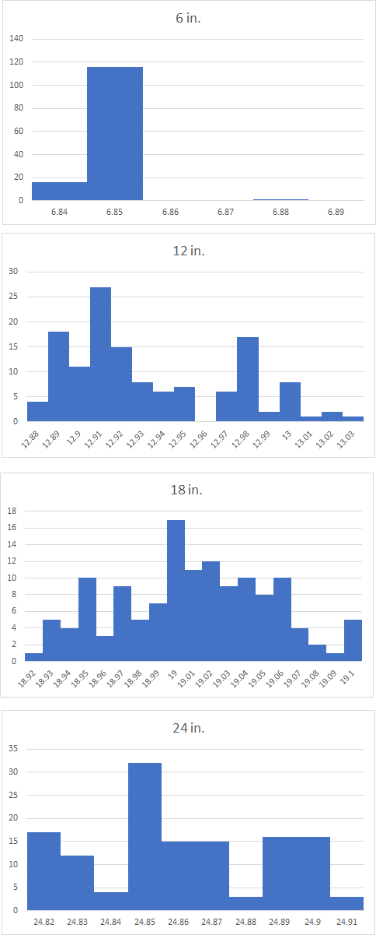

After gathering the data we modified our code to produce an offset of 0.85 for the ultrasonic sensor distance. Our updated code is located in the Appendix. We captured over 100 measurements for both 10 and 20 inches. Our results are displayed below.

Table 2: Updated Variance and Mean of the Statistical Data for 3rd Sensor

|  |  |  |
| --- | --- | --- |
| inch: | 10 | 20 |
| mean | 10.02445205 | 19.99452055 |
| variance | 0.00114900803 | 0.002284251299 |
| DIFF | 0.02445205479 | 0.005479452055 |

Figure 4. Histogram for 10 inches for updated code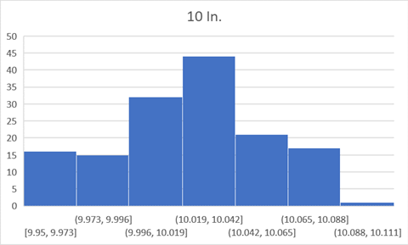

Figure 5. Histogram for 20 inches for updated code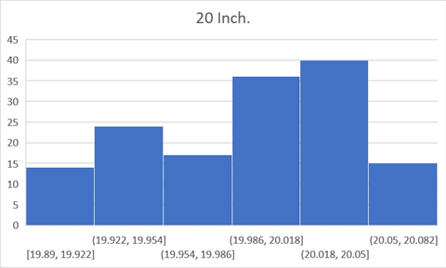

Conclusion:

We selected the third sensor based on its incredibly low variance. Afterwards we modified our code to adjust for a 0.85 overshoot our code performed well by changing the difference from 0.84 to 0.02 (190% improvement) for the 10 inch calculation and 0.005 (197% improvement) for the 20 inch calculation. The metric worked very well for farther distances, as the DIFF was smaller for 20 inches than 10 inches.

We look forward to speaking with you soon,

*Sys Tems, LLC Engineering Department.*

References:

*How Does the HC-SR04 Ultrasonic Sensor Used to Calculate Distance?*, forum.arduino.cc/index.php?topic=447753.0.

Pineda, Andres, director. *How To: Use an Arduino with an Ultrasonic Sensor (HC-SR04)*. 2017.

________

Appendix:

#define echoPin 10

#define trigPin 9

double duration;

double distance;

void setup() {

Serial.begin(9600);

pinMode(echoPin, INPUT);

pinMode(trigPin, OUTPUT);

//Setting up digital display for shits and giggles

}

void loop() {

digitalWrite(trigPin, LOW);

delayMicroseconds(2);

digitalWrite(trigPin, HIGH);

delayMicroseconds(10);

digitalWrite(trigPin, LOW);

duration=pulseIn(echoPin, HIGH);

//Distance in CM conversion to inches

distance=(duration/58.2)/2.54;

Serial.println(distance);

delay(50);

}

**Updated code:**

#define echoPin 10

#define trigPin 9

double duration;

double distance;

void setup() {

Serial.begin(9600);

pinMode(echoPin, INPUT);

pinMode(trigPin, OUTPUT);

//Setting up digital display for shits and giggles

}

void loop() {

digitalWrite(trigPin, LOW);

delayMicroseconds(2);

digitalWrite(trigPin, HIGH);

delayMicroseconds(10);

digitalWrite(trigPin, LOW);

duration=pulseIn(echoPin, HIGH);

//Distance in CM conversion to inches

distance=(duration/58.2)/2.54 - .91;

Serial.println(distance);

delay(50);

}